Monorath:Asabina Violates Human Rights With Statements Regarding Homosexuality

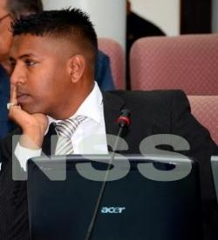
Harish Monorath (Nieuw Suriname)
Member of Parliament Ronny Asabina (BEP) has angered homosexuals, heterosexuals but especially fellow Parliament member Harish Monorath (Nieuw Suriname). The Netherlands is also very shocked by his statements. Dutch political party PVV shall definitely ask questions about this matter. Asabina has firmly expressed his views on homosexuality and feels it should be erradicated. Monorath feels that a member of Parliament should not make such statements.
At the first public Assembly meeting, Monorath shall demand an apology from the Parliament for Asabina's statements. The next meeting is scheduled for Thursday. Monorath also feels that Asabina should be reprimanded by the Parliament. “It is safe to say that with his statements, Asabina has violated human rights. He has chracterized himself as a violator of human rights," says Monorath.
Freedom of Choice
Monorath says that a person's sexual orientation is a free choice. Freedom of choice is held high and honored in national and international declarations. “No one has the right to codemn a person's sexual orientation, be they a member of Parliament or not." For this reason, laws concerning divorce were changed in 2004. “Cheating or sexual orientation are no longer valid reasons. No one should stay in an unhealthy relationship," says Monorath. According to Monorath, Asabina wants to bring society back to the prehistoric era. “Suriname has some ten thousand homosexuals. Should we violate their human rights?" Monorath asks. According to Monorath ,Asabina cannot speak for the entire Maroon culture. “I visit frequent varios nightclubs, most homosexual men are Maroon or of Indian descent," he says. Monorath says most men don't label themselves as homosexual, but they think of it as enjoying another man's company." That's called MSM (men who have sex with men). Usually they are married men who choose to engage in sexual activities with men. “It is typical for the Caribbean where the macho man culture dominates." Monorath also feels that homosexuality should not be brought in relation with the HIV virus. Personal opinions such as those of Asabina will make it difficult to fight against HIV amongst homosexual men.

